בַּשָּׁמַ֣֨יִם֙
Ezra SIL Hebrew Unicode Fonts
Installation Guide


SIL International

NRSI-Ezra-070327152600-01

Table of Contents
Table of Contents 2
Installation Guide: Ezra SIL Hebrew Unicode Fonts 4
Introduction 4
License 5
Overview of the Ezra SIL Fonts 6
Installation and Setup in Microsoft® Windows® 8
Uniscribe Update Required 8
Windows 98 SE Installation 8
Windows 2000/XP Font Installation 8
Windows 2000/XP Keyboard Installation 9
Tiro Keyboards 9
Keyman Keyboards 9
Keyman Install 9
Package Install 10
Keyboard Install 10
Office 2000 Language Settings 10
Office XP Language Settings 11
Input Locales (for Windows 2000) 12
Using the Keyboard in Windows 2000 13
Input Locales (Text Services for Windows XP) 13
Using the Keyman Keyboard in Windows XP 15
Opening a File - Word 2000 15
Opening a File - Word 2002 16
Graphite and AAT 18
Uninstalling a Font, Input Locale, and Keyboard in Windows 2000/XP 19
Conversion Installations 20
TECkit Installation 20
Installation 20
CC Installation 20
Installation 20
Utilities 21
Unicode Word Macros 21
Unicode BMP Fallback Font 21
TTF Extension 21
Technical Support 21

Installation Guide: Ezra SIL Hebrew Unicode Fonts

Introduction
The associated files with this package constitute the Ezra SIL Hebrew Unicode Fonts. SIL International (SIL) is an organization of linguists dedicated to the study and promotion of the thousands of languages around the world. We are happy to make these OpenType® fonts available to the general public at no charge. You may (and are encouraged to) share these fonts with your friends and co-workers, but with the following restrictions:
- All files must be copied together, including this one.
- No fee may be charged for the fonts.
- They may not be used as a basis for other fonts.
Even though these fonts are “free,” SIL retains all copyright and ownership of the included fonts and reserves the right to restrict their use and distribution at any time. They may be placed on websites, etc. but cannot be included in (or bundled with) any commercial product including hard disks or CD-ROMs without specific written permission.
The Ezra SIL fonts contain all the symbols defined in Unicode 5.0 for Latin-1 and Hebrew and is supplied in Regular typeface.
In addition to the fonts themselves, this package includes keyboards which simplify the typing of Hebrew text. Users may produce their own keyboard file, if desired.
SIL wishes to thank Ralph Hancock for providing the OpenType programming for these fonts. Also John Hudson of Tiro Typeworks for providing the new keyboard. Thanks also to Eli Evans of Libronix Corporation and Paul Nelson of Microsoft Corporation for their significant contributions with the others to the Unicode discussions in May 2003. We are deeply indebted.

License
Hebrew layout intelligence copyright (c) 2003 & 2007 Ralph Hancock and John Hudson, and licensed under the MIT/X11 License (copied below).
All other font software is copyright (c) 1997-2007, SIL International ( http://www.sil.org/), with Reserved Font Names "SIL" and "Ezra", and is licensed under the SIL Open Font License, Version 1.1. This license is copied below, and is also available with a FAQ at: http://scripts.sil.org/OFL

MIT/X11 License (only for Hebrew layout intelligence)
Permission is hereby granted, free of charge, to any person obtaining a copy of this software and associated documentation files (the "Software"), to deal in the Software without restriction, including without limitation the rights to use, copy, modify, merge, publish, distribute, sublicense, and/or sell copies of the Software, and to permit persons to whom the Software is furnished to do so, subject to the following conditions:
The above copyright notice and this permission notice shall be included in all copies or substantial portions of the Software.
THE SOFTWARE IS PROVIDED "AS IS", WITHOUT WARRANTY OF ANY KIND, EXPRESS OR IMPLIED, INCLUDING BUT NOT LIMITED TO THE WARRANTIES OF MERCHANTABILITY, FITNESS FOR A PARTICULAR PURPOSE AND NONINFRINGEMENT. IN NO EVENT SHALL THE AUTHORS OR COPYRIGHT HOLDERS BE LIABLE FOR ANY CLAIM, DAMAGES OR OTHER LIABILITY, WHETHER IN AN ACTION OF CONTRACT, TORT OR OTHERWISE, ARISING FROM, OUT OF OR IN CONNECTION WITH THE SOFTWARE OR THE USE OR OTHER DEALINGS IN THE SOFTWARE.

SIL OPEN FONT LICENSE Version 1.1 - 26 February 2007

PREAMBLE
The goals of the Open Font License (OFL) are to stimulate worldwide development of collaborative font projects, to support the font creation efforts of academic and linguistic communities, and to provide a free and open framework in which fonts may be shared and improved in partnership with others.
The OFL allows the licensed fonts to be used, studied, modified and redistributed freely as long as they are not sold by themselves. The fonts, including any derivative works, can be bundled, embedded, redistributed and/or sold with any software provided that any reserved names are not used by derivative works. The fonts and derivatives, however, cannot be released under any other type of license. The requirement for fonts to remain under this license does not apply to any document created using the fonts or their derivatives.

DEFINITIONS
"Font Software" refers to the set of files released by the Copyright Holder(s) under this license and clearly marked as such. This may include source files, build scripts and documentation.
"Reserved Font Name" refers to any names specified as such after the copyright statement(s).
"Original Version" refers to the collection of Font Software components as distributed by the Copyright Holder(s).
"Modified Version" refers to any derivative made by adding to, deleting, or substituting — in part or in whole — any of the components of the Original Version, by changing formats or by porting the Font Software to a new environment.
"Author" refers to any designer, engineer, programmer, technical writer or other person who contributed to the Font Software.

PERMISSION & CONDITIONS
Permission is hereby granted, free of charge, to any person obtaining a copy of the Font Software, to use, study, copy, merge, embed, modify, redistribute, and sell modified and unmodified copies of the Font Software, subject to the following conditions:
1) Neither the Font Software nor any of its individual components, in Original or Modified Versions, may be sold by itself.
2) Original or Modified Versions of the Font Software may be bundled, redistributed and/or sold with any software, provided that each copy contains the above copyright notice and this license. These can be included either as stand-alone text files, human-readable headers or in the appropriate machine-readable metadata fields within text or binary files as long as those fields can be easily viewed by the user.
3) No Modified Version of the Font Software may use the Reserved Font Name(s) unless explicit written permission is granted by the corresponding Copyright Holder. This restriction only applies to the primary font name as presented to the users.
4) The name(s) of the Copyright Holder(s) or the Author(s) of the Font Software shall not be used to promote, endorse or advertise any Modified Version, except to acknowledge the contribution(s) of the Copyright Holder(s) and the Author(s) or with their explicit written permission.
5) The Font Software, modified or unmodified, in part or in whole, must be distributed entirely under this license, and must not be distributed under any other license. The requirement for fonts to remain under this license does not apply to any document created using the Font Software.

TERMINATION
This license becomes null and void if any of the above conditions are not met.
DISCLAIMER THE FONT SOFTWARE IS PROVIDED "AS IS", WITHOUT WARRANTY OF ANY KIND, EXPRESS OR IMPLIED, INCLUDING BUT NOT LIMITED TO ANY WARRANTIES OF MERCHANTABILITY, FITNESS FOR A PARTICULAR PURPOSE AND NONINFRINGEMENT OF COPYRIGHT, PATENT, TRADEMARK, OR OTHER RIGHT. IN NO EVENT SHALL THE COPYRIGHT HOLDER BE LIABLE FOR ANY CLAIM, DAMAGES OR OTHER LIABILITY, INCLUDING ANY GENERAL, SPECIAL, INDIRECT, INCIDENTAL, OR CONSEQUENTIAL DAMAGES, WHETHER IN AN ACTION OF CONTRACT, TORT OR OTHERWISE, ARISING FROM, OUT OF THE USE OR INABILITY TO USE THE FONT SOFTWARE OR FROM OTHER DEALINGS IN THE FONT SOFTWARE.

Overview of the Ezra SIL Fonts
The Ezra SIL fonts are the identical typeface to the SIL Ezra font released by SIL in 1997. The font was developed from the beautiful Biblia Hebraica Stuttgartensia volume which is familiar to many biblical Hebrew scholars. It is a regular typeface, with no bold or italic version.
The Ezra SIL fonts differ significantly from SIL Ezra in the following ways:
- They are TrueType fonts with OpenType® ‘smart font’ capability added. This means that the placement of diacritics is handled by the font and Microsoft’s Uniscribe program, provided you are running an application which supports OpenType, such as Microsoft Word®. With the old fonts, diacritic placement was handled by the very complex keyboard and by having multiple versions of a given diacritic in the font itself.
- They are Unicode fonts. The encoding is entirely different from the old SIL Ezra fonts. Data typed with the old fonts will have to be converted or re-typed before it will display with the Ezra SIL fonts. The Ezra SIL fonts will only work in applications which support Unicode and OpenType.
- There are two Ezra SIL fonts. Ezra SIL matches the SIL Ezra typeface and cantillation, with a few typeface corrections. Ezra SIL SR has a different style of cantillation, previously only available with the Macintosh® GX version of SIL Ezra.
- The Latin-1 codepage (“A-Z”, “a-z” plus some punctuation, etc.) is also included in the font. This is to assist with viewing Latin or Roman text, but we do not recommend using Ezra SIL primarily for Latin. The main reason is we have substituted Hebrew-style punctuation for some of the Latin punctuation, since those characters are not assigned separately for Hebrew in Unicode (see ; , . , etc.).
- If you are working with a Unicode-compliant application, you should be able to type Hebrew right-to-left without the special utilities previously required.
- You will need to use a keyboard program, but can use any Hebrew Unicode keyboard you prefer. The keyboards provided in this package are designed to match the old SIL Ezra DE keyboard. You can also use it as a basis for developing your own keyboard.

The Ezra SIL v.2.5 fonts differ from earlier versions in the following ways:
- The PUA characters have been replaced.
- A stricter input order is required. In brief, all low cantillation marks must precede all high cantillation marks.
- The Ezra SIL SR font no longer merges sin dot with holam, but displays both.
- The new code points defined in Unicode 4.1 have been added.
- The handling of vocalic holam-waw and consonantal waw-holam has changed to conform to Unicode 5.0.

Installation and Setup in Microsoft® Windows®
Follow the instructions below, according to your operating system. The release will be available in a number of compressed formats. The Zip format is used in these instructions. These fonts are designed to work with Office 2003. Part of the code for handling biblical Hebrew is in that release.

Uniscribe Update Required
Increasing numbers of applications are becoming available which can handle Unicode, including right-to-left scripts. Microsoft has made a commitment to making their software Unicode-compliant, and they do make updates available from time to time. To view fully-cantillated Hebrew, you will need the version of Uniscribe (usp10.dll) that was released with Office 2003. Having an updated Uniscribe will greatly reduce the number of dotted circles (U+25CC) which currently appear in Hebrew data. It will also improve the display of Hebrew diacritics in many cases. The updated version of Uniscribe is available in Office 2003, BART 5 and Paratext 6 (available to Bible translators only) and other software such as Libronix. The version number should needs to be at least 1.468.4015.0, dated 3-31-2003.

Windows 98 SE Installation
It is possible to use the Ezra SIL Unicode fonts in Windows 98 SE. However, it involves loading Hebrew support from Internet Explorer, version 6 and depends on the availability of an updated Uniscribe. We have not done extensive testing on this system and can offer no assistance. These fonts were designed for Windows 2000 or XP.

Windows 2000/XP Font Installation
The Ezra SIL fonts can be installed just like any other TrueType font. You may use any font installer programs you have, or the Control Panel application supplied with Windows.
If you will be using the Keyman 6 keyboard, the fonts will be installed for you. Skip to “Package Install” below. Note you must also install Keyman, if you haven’t already.
Font installation using the Control Panel is summarized below.
- Double-click the EZRSIL25.zip file and extract all files to a folder of your choice.
- Click Start / Settings / Control Panel or Start / Control Panel.
- Double-click on the Fonts icon to bring up the Fonts dialog.
- Find and delete any old version(s) of the font Ezra SIL or Ezra SIL SR. You do not have to delete any SIL Ezra font.
- On the menu, click File / Install New Font... to bring up the Add Fonts dialog.
- Open the Drives list and select the drive where you have unzipped the Ezra SIL release. Then under Folders:, navigate to the folder Ezra SIL Release 2.5 and under that, the Fonts folder. In a few seconds the name of the fonts (Ezra SIL (TrueType) and Ezra SIL SR (TrueType)) will appear in the List of Fonts.
- In the same window, Copy fonts to Fonts folder should have a checkmark.
- Click the font names to select (or Select All), and then OK. In a few seconds, the fonts will be listed in the Installed Fonts list.
- Click on File / Close or exit the window.
Note that certain applications may not see the new fonts immediately. You may have to quit and restart the application for the fonts to become available.

Windows 2000/XP Keyboard Installation
If you only wish to view Hebrew text, not type it, you can skip to your version of Office Language Settings, below.
Any of the keyboards listed below should work correctly with any Unicode Hebrew font.

Tiro Keyboards
A new kind of keyboard has been made available with this release. It was done by John Hudson of Tiro Typeworks. It uses Microsoft Keyboard Layout Creator and is easy to install. The layout of the SIL version is similar to the original SIL Ezra de keyboard. For installation instructions and layout, print out BiblicalHebrew(SIL)Manual.pdf from the Tiro Keyboards folder.
This keyboard will not work with Word 2000 because Word controls many of the Alt key combinations needed. It works well in Word 2002.
An Israeli-style layout keyboard is also included in Tiro Keyboards for those who prefer that layout. See BiblicalHebrew(Tiro)Manual.pdf for installation and printed keyboard layout.
If you choose to use the Tiro keyboards, you may skip the following Keyman instructions. After installing the Tiro keyboard(s), go to “Opening a File” for Windows 2000 or XP.

Keyman Keyboards
Keyman 5 or higher is needed for using the ezrauni23.kmx keyboard. Keyman’s latest version is available from http://www.tavultesoft.com. If you will be creating or modifying keyboard layouts, you will need the Developer version. The regular version up to 6.0.164 was a free product for personal use.
If you already have an up-to-date Keyman application installed, skip the directions for “Keyman Install” below and go to “Package Install” or “Keyboard Install.”

Keyman Install
- Uninstall any previous versions of Keyman.
- Install Keyman, following the installation instructions provided with Keyman.
- If you haven’t run Keyman for the first time yet, go to Start / Programs / Tavultesoft Keyman / Keyman (or whatever location you chose during install.)
- This will briefly show an ‘About’ screen and place the Keyman icon in your system tray (bottom right of screen).
- Register your copy by right-clicking this icon (a rotated key with a 'k'), then click About Keyman… / Register.
- For Keyman 5, right click the Keyman icon, and click ‘Start with Windows’ if you want Keyman to be available each time you start-up. For Keyman 6, right-click the Keyman icon, click Keyman Configuration.... Click the Options tab and checkmark “Start Keyman with Windows.” Click OK.

Package Install
You can install the fonts, the ezrauni23.kmx keyboard, and the ezrauni23.kvk visual keyboard in one step below. OR go to “Keyboard Install” for the original keyboard installation directions.
- Just double-click the ezrauni23.kmp file.
- Continue the installation by going to your version of Office Language Settings, below. Access to the visual keyboard is done with a right-click on the Keyman icon in the System Tray. Then select Visual keyboard.

Keyboard Install
The new Unicode keyboard is ezrauni23.kmx.
- Install this keyboard by right-clicking the Keyman icon on your system tray.
- Click Keyman Configuration...
- Click the Install Keyboard… button.
- Browse to the location of the file ezrauni23.kmx. Choose it from the Keyboards5 or Keyboards6 folder, depending on your version of Keyman.
- Click ezrauni23.kmx to select it. Then click Open, choose a hotkey (one is already selected for you but you may choose another one or choose none), then Install. For Keyman 6, choose the hotkey after selecting Install. Then click OK. You should get a message saying the keyboard was installed successfully.
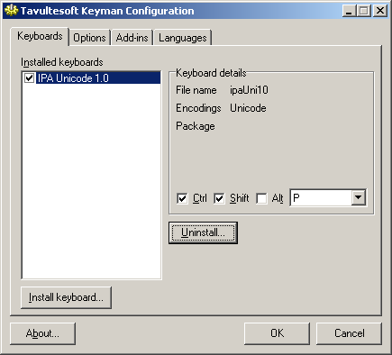
- Click OK and OK.
- Continue with your version of Language Settings below.

Office 2000 Language Settings
To work with a keyboard in Windows, you must associate it with a language in
Start / Programs / Microsoft Office Tools / Microsoft Office Language Settings. If not already installed, select Hebrew.

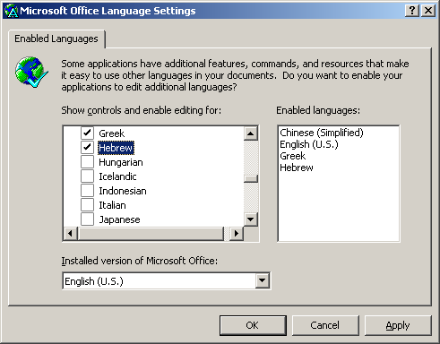

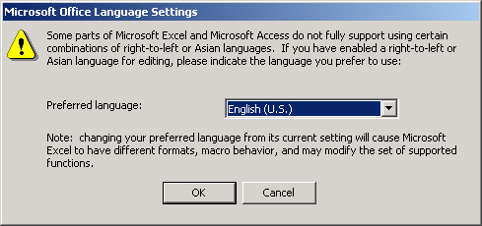
When you click Apply, you may then be asked the following:

You may be asked for your Office 2000 CD to be inserted. Follow the directions on the screen.

Office XP Language Settings
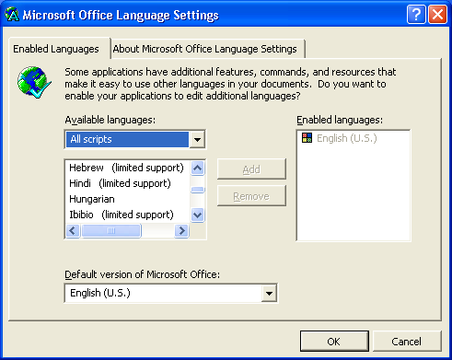
To work with a keyboard in Windows, you must associate it with a language. Go to
Start / Programs / Microsoft Office Tools / Microsoft Office XP Language Settings or Start / All Programs ... depending on your settings.

In the graphic above, Hebrew has not yet been installed. Click on Hebrew to select it, then click Add and then OK. Follow the directions on the screen. You can delay restarting until finishing the installation.

Input Locales (for Windows 2000)
- If this is the first time you have used Hebrew, you will need to install it. Go to Start / Settings / Control Panel / Regional Options. Select Hebrew and you will be asked to insert your Windows 2000 CD (a different one than the one just used). Follow the directions on the screen. Click Restart and immediately take the CD out! You should only need to do this once.
- Go to Start / Settings / Control Panel / Regional Options or right-click on the language icon in the system tray (‘EN’ if English) and select Properties.
- Click the Input Locales tab.
- Either click Add or highlight the Hebrew input locale and click Properties. You can have more than one Hebrew locale.
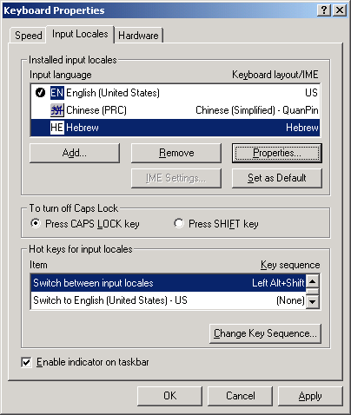
5. Set the keyboard to Ezra SIL Unicode23.
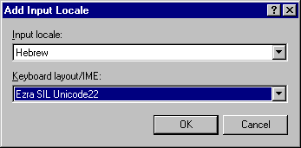
6. Click OK / Apply / OK. Once you have the Keyman keyboard associated with Hebrew, you should switch it on and off only using the input locale icon (“HE”). This button is located on the System Tray. You shouldnot use the Keyman icon. Close the Control Panel window.
7. Restart your computer.

Using the Keyboard in Windows 2000
To use the keyboard, go to your application, set the font to Ezra SIL or Ezra SIL SR. Click the language icon on your system tray ('EN' for English) and select HE Hebrew - Ezra SIL Unicode23 as the keyboard. In Word, you can click the left-pointing paragraph icon (Right-to-Left) found on the Formatting toolbar if you wish the entire paragraph to be right-to-left.. Begin typing. The keyboard layout is described in the documentation folder.

Input Locales (Text Services for Windows XP)
- Go to Start / Settings / Control Panel / Regional and Language Options or Start / Control Panel... or right-click on the language icon in the system tray (‘EN’ if English) and select Properties.
- Select the Languages tab. Make sure the box “Install files for complex scripts and right-to-left languages (including Thai)” is checked.
- If not, (a) check it.
(b) Click OK.
(c) Click Apply.
(d) You may need to insert your Windows installation CD.
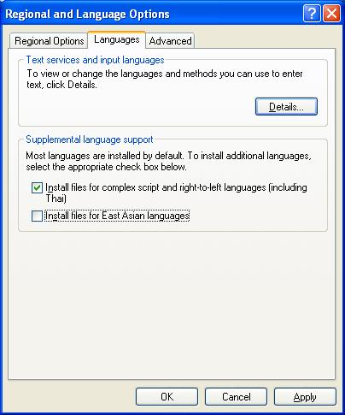
(e) you will need to reboot your computer before proceeding to the next step.
- Click the Details… button. To add the keyboard, click Add.
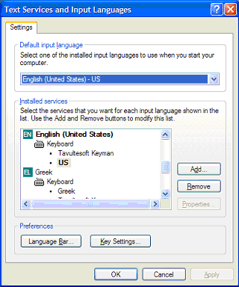
- Set the Input Language to Hebrew and the keyboard to Ezra SIL Unicode23.
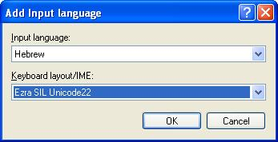
- Click OK. Once you have the Keyman keyboard associated with Hebrew, you should switch it on and off only using the Language Bar icon (“HE”) on the system tray. You shouldn’t use the Keyman icon.
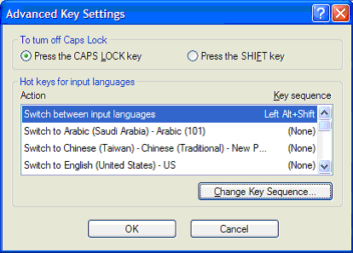
- From the Text Services window, you will also need to turn off keyboard switching. Go back by clicking Details…. Click once on HE Hebrew so it is highlighted. Click Key Settings.
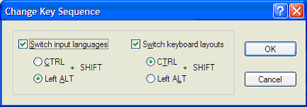
- Click Change Key Sequence while “Switch between input languages” is highlighted. Uncheck both boxes. Click OK, OK, OK and OK. You will have to reset this every time you install a keyboard. The default setting interferes with any keyboard that uses Alt-Shift or Ctrl-Shift..

- Close the Control Panel window.
- Restart your computer.
Note: You may install more than one keyboard for a given language. For instance, you can assign more than one keyboard to Hebrew, or add a keyboard for a language which also has a system keyboard. If a language has multiple keyboards assigned, you will see a small ‘keyboard’ icon appear in the system tray when you select that language. Click it and select the keyboard you wish to use.

Using the Keyman Keyboard in Windows XP
To use the Keyman keyboard, go to your application, set the font to Ezra SIL or Ezra SIL SR. Click the language icon on your system tray or Language Bar (“EN” for English) and select HE Hebrew as the language. Then click the small ‘keyboard’ icon on the system tray and select the keyboard “Ezra SIL Unicode23.” (This step is only needed if you have more than one Hebrew keyboard installed.) In Word, you can click the left-pointing paragraph icon (Right-to-Left) found on the Formatting toolbar if you wish the entire paragraph to be right-to-left. Begin typing. The keyboard layout is described in the Documentation folder.

Opening a File - Word 2000
- It is preferable to have Word ask you what type of file you are opening. To ensure this happens, click Tools / Options / General. Make sure that the box beside Confirm Conversion at Open is checkmarked.
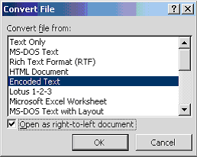
- Open Gen.txt in Word. It is found in the Documentation folder. When the “Convert File” window appears, make sure “Encoded Text” is highlighted. Check the “Open as right-to-left document” box at the bottom. Click OK.
- In the File Conversion window, Other encoding should be selected. Make sure “Unicode (UTF-8)” is highlighted. Click OK.

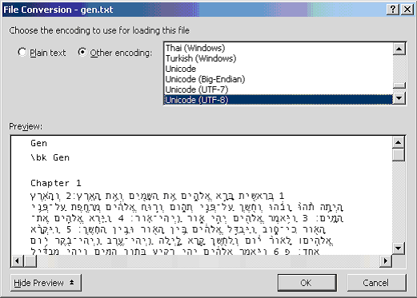
- Edit / Select All and right-align using the Paragraph button that points left.
- With all text still selected, change the font to Ezra SIL and choose a point size.
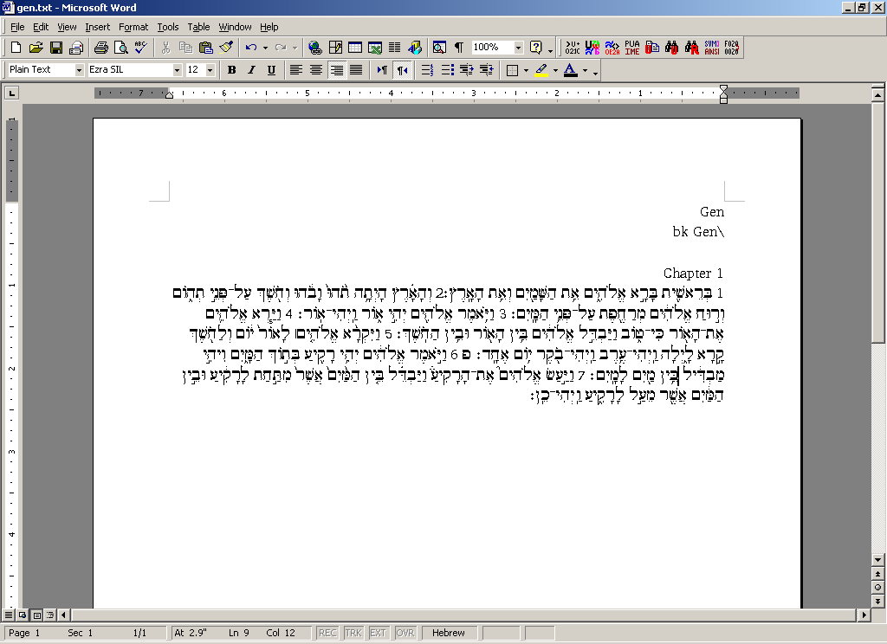
- With all text selected, double-click the box that says what language this is and if necessary, change to Hebrew. It’s at the bottom center of the screen on the same line as Page and Sec. It may say Arabic Saudi Arabia. The desired results are below:
When the cursor is in an English section, it will say English. Click on a Hebrew line to check that it is now Hebrew.

Opening a File - Word 2002
- It is preferable to have Word ask you what type of file you are opening. To ensure this happens, click Tools / Options / General. Make sure that the box beside Confirm Conversion at Open is checkmarked.
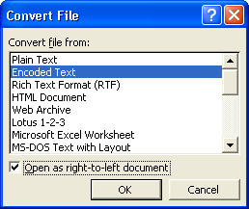
- Open gen.txt in Word 2002. It is found in the Documentation folder. Click “Open as Right-to-Left document” either here or in the following window.

- Make sure “Other encoding” and “Unicode (UTF-8)” is highlighted. Document direction should be “Right-to-left”. Click OK.
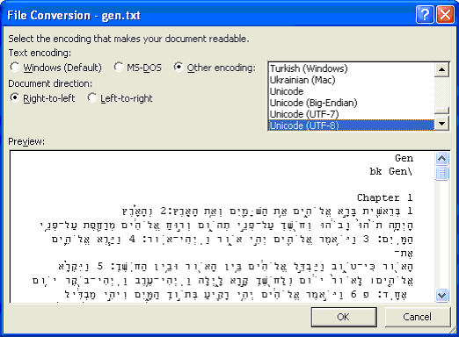
- Edit / Select All, change the font to Ezra SIL and choose a point size.
- With all text selected, double-click the box that says what language this is and if necessary, change to Hebrew. It’s at the bottom center of the screen on the same line as Page and Sec. It may say Arabic Saudi Arabia. The desired results are below:

When the cursor is in an English section, it will say English. Click on a Hebrew line to check that it is now Hebrew. On the first installation of the Ezra SIL font, it may not display at all and Windows will substitute another Hebrew font. Try selecting Ezra SIL SR or typing Hebrew using Ezra SIL SR or Ezra SIL. It should load eventually. Restarting does not help this problem.

Graphite and AAT
The project to produce an AAT-enabled version (for Macintosh) of the Ezra SIL Unicode fonts has been discontinued. There are no plans at this time to produce a Graphite-enabled version.

Uninstalling a Font, Input Locale, and Keyboard in Windows 2000/XP
Fonts can be deleted and re-installed without interfering with either keyboards or the input locale. You may use any font uninstall utility, or follow these directions:
- Click Start / Settings / Control Panel or Start / Control Panel . Double-click Fonts.
- Scroll down to “Ezra SIL” and/or “Ezra SIL SR” and click once to highlight.
- Click File / Delete. Click Yes to delete.
- Close the Fonts window.
The Input Locale should be deleted before uninstalling the keyboard from Keyman. Follow the uninstall directions in the Tiro manuals if you are using Tiro keyboards.
- Right-click the language icon (EN for English) on your system tray.
- Click Properties (Settings in Windows XP).
- Scroll down to the Hebrew input locale and the Ezra SIL Unicode23 keyboard. Click once to highlight.
- Click Remove. Click Apply and OK.
- Close the Input Locales window.
- Right-click the Keyman icon in your system tray.
- Click Keyman Configuration....
- Click Ezra SIL Unicode23 once to highlight.
- Click Uninstall... Click OK, OK, and OK.
The keyboard and its input locale are now deleted. You may need to repeat deleting the Hebrew input locale to completely remove it.

Conversion Installations
See the new Conversion Guidelines for more information on how to convert SIL Ezra texts or the Westminster Leningrad Codex (in Michigan-Claremont encoding) to Unicode. The following programs may be needed. In some browsers you may have to right-click and “Save Target As...” rather than clicking the item to download.

TECkit Installation
TECkit mapping tables for conversion have been added to the 2.5 release of the Ezra SIL fonts. These can be used in conjunction with the easy-to-use TECkit conversion program, which is available without charge from http://www.sil.org or directly from http://scripts.sil.org/TECkit. Choose the first zip file under the TECkit Downloads under the heading “Windows release.”

Installation
Double-click the zip file.
Copy TECkit.exe, SFConv.exe, and TECkit_x86.dll to an appropriate location, such as C:\Program Files\TECkit. These files must be either in the same folder as the text files you are converting or on your PATH. If you don’t know what the PATH is, just keep an extra copy of these files wherever you wish to run the conversion. Create a shortcut on your desktop for this file. To do this, right-click the filename, select Send to / Desktop(create shortcut).
You do not need the other files unless you wish to learn more about TECkit and write your own mappings.

CC Installation
The Consistent Changes or CC program can be used for conversion of Michigan-Claremont texts to SIL Ezra Standard Encoding. From there, the text could be converted to Unicode using TECkit. One of the TECkit mappings supplied with the fonts can be used in TECkit to do this directly. To download CC, see http://www.sil.org/computing/catalog/show_software.asp?id=4 Choose CC 8.1.6 Program. You will not need the documentation unless you are planning to write your own programs using CC.

Installation
Double-click the CC8_1_6.ZIP file.
Copy the CCW32.exe file from the CCWin folder to an appropriate location on your hard disk, such as C:\Program Files\CCWin. Create a shortcut on your desktop for this file. To do this, right-click the filename, select Send to / Desktop (create shortcut).
Copy both CC.dll and CC32.dll from the CCWin\DLL folder into your system’s \Windows\System folder, normally on the C: drive.
You do not need the other files unless you wish to learn more about CC and write your own CC programs.
If you wish to write your own conversion for Hebrew, you may find it helpful to review the TECkit and CC mapping sources (included in the Ezra SIL release). A chart is also provided showing the different encodings and how they relate to Unicode. See Unicode Ezra Chart17short.pdf.

Utilities
Some useful products for working with Unicode data are also available on the website.

Unicode Word Macros
For a means to display the Unicode value of any character, to enter any Unicode (with some restrictions), and to search for any Unicode character in Microsoft Word, look at:
http://scripts.sil.org/UnicodeWordMacrosIntro

ABS Macros
Where Word has not recognized the right-to-left direction of part of the Hebrew text, this may be corrected by explicit setting of a stretch of text as right-to-left. It is available from http://scripts.sil.org/RTL_in_MSOffice

Unicode BMP Fallback Font
For a font that displays the 4-digit Unicode value of each character in a selected text, look for the Unicode BMP Fallback font, available from http://scripts.sil.org/UnicodeBMPFallbackFont

TTF Extension
To see more information about your fonts, such as License, Distribution Restrictions, Names, and Version number with this Microsoft extension available here:
http://www.microsoft.com/typography/property/property.htm

Technical Support
As these programs are provided free, we cannot offer a commercial level of support. However, if you find errors or other problems using the Ezra SIL Hebrew Unicode Fonts, we would like to know. We can be contacted at:
User Support
SIL International Publishing Services
7500 W. Camp Wisdom Rd.
Dallas, TX 75236
USA
E-mail: sil_fonts@sil.org

